Bystander Intervention is a 90 minute workshop administered by Crisis Services of Buffalo. This workshop is presented to the following student leaders at Daemen College: Athletes, Greek Life, Orientation Leaders, Peer Mentors, Resident Advisors, and Tour Guides. Students are asked to participate in a pre and post test survey. The results of those surveys are presented below.

Demographics:
Gender | Females: 174 | Males: 102 | Unspecified: 1
Age | Seventeen: 12 | Eighteen: 50 | Nineteen: 77 | Twenty: 69 | Twenty - One: 52 | Twenty - two: 14 | Twenty - Three or older: 2
Race | African - American: 26 | Caucasian: 208 | Hispanic: 9 | Two or more races: 11 | Other: 12
Class Year | First-Year: 49 | Sophomore: 78 | Junior: 78 | Senior: 51 | Graduate: 17 | Other: 4
Student Groups | Athletics: 155 | Greek Life: 41 | Orientation Leader: 21 | Peer Mentor: 23 | Resident Advisor: 16 | Tour Guide: 20
Experience with Bystander Intervention Training | Yes: 92 | No: 136 | Unsure: 12 | Not Asked On Survey: 10 | Not Specified: 27

The following charts show the average responses on the pre and post test survey by question and by topic area:

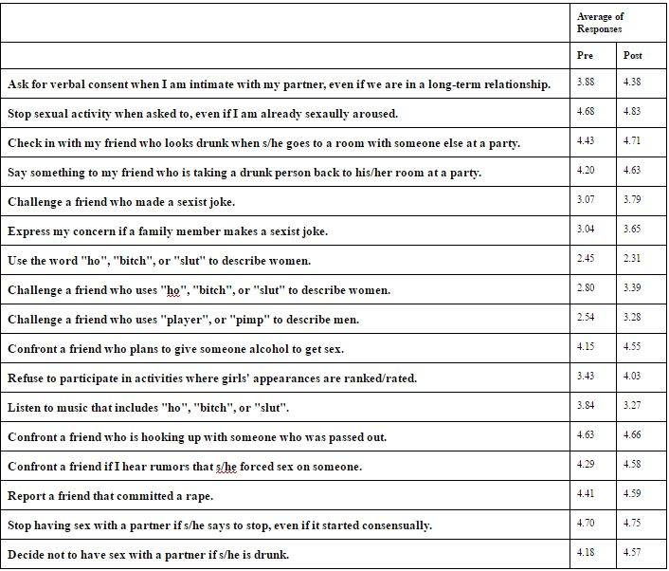

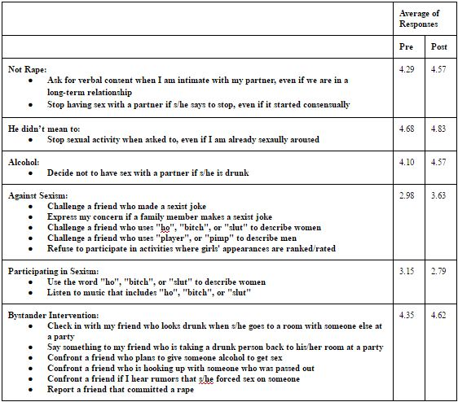

The following charts show the average response rates of certain demographic groups for both the pre and post test.

Gender:
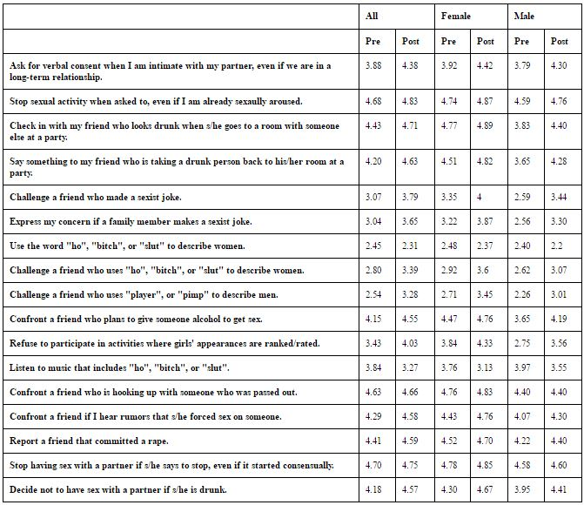

The results show that women are actually more likely than men to use words like “ho”, “bitch”, or “slut” to describe women. The results also show the men are less likely than women to challenge a friend who uses “player” or “pimp” to describe men. These two results may provide insight into how students act within groups of the same gender versus co ed environments.

Class Year:
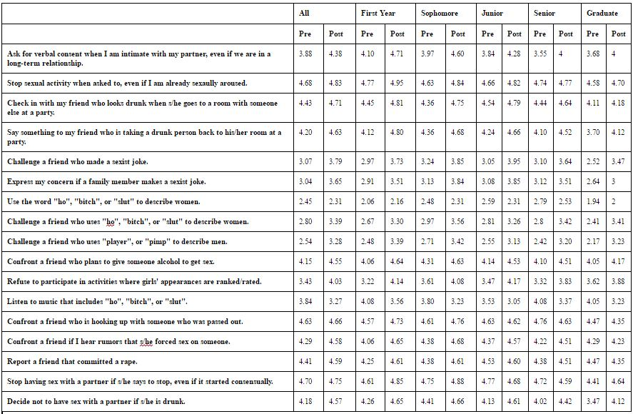

It is interesting to note that First Year and Sophomore students seemed more likely to be willing to intervene than older students.

Student Groups:
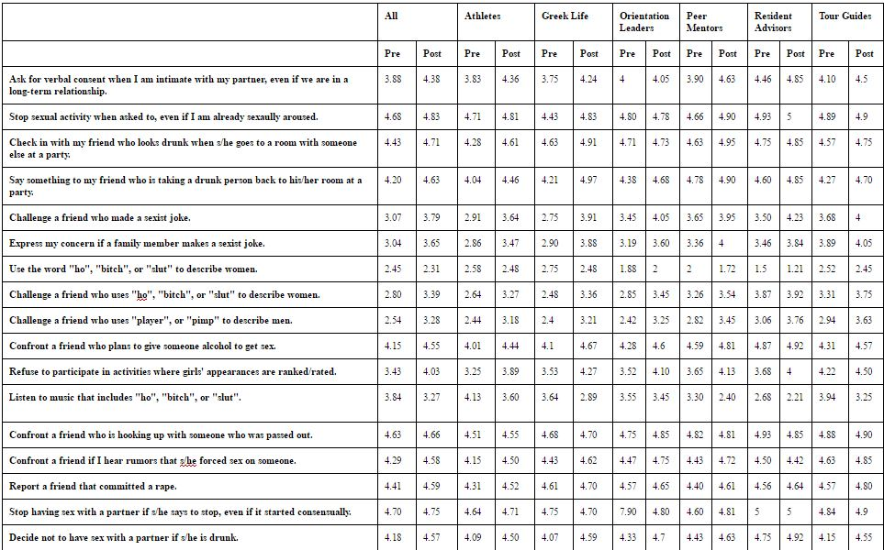

In regards to student organizations, RA seemed to be the most knowledgeable about topics of consent and intervention. This could also be due to other trainings RAs receive in conjunction with Bystander Intervention training.

Experience with Bystander Intervention Training:
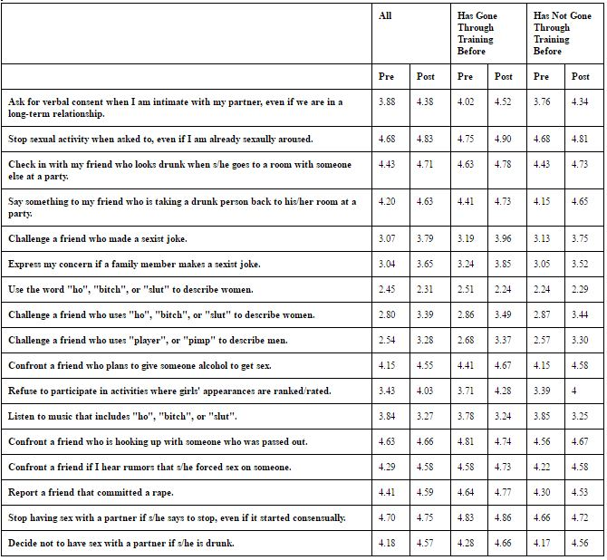

In most categories, students who had participated in the training before generally showed a higher level of learning than those who had not participated.

As part of the post test survey, students were asked to list one thing they learned through Bystander Intervention Training. The top three trends that arose in student responses were intervention, consent, and tips for communicating with survivors of sexual violence.

A Peer Mentor noted that “Anyone can intervene and change the outcome of a dangerous situation”.

A Tour Guide mentioned “I wouldn’t have thought about the fact that the victims would need to gain power & control back when helping them”.

A member of Greek Life stated “There's a difference between a witness and an active witness. A witness just sees whats going on and doesn’t do anything and an active witness steps in to help. Positive bystander intervention is always possible before, during, after”.

An Athlete said “I learned that sexual violence is more than just rape”.

Students were also asked to list ways in which they could directly intervene, delegate an intervention, and distract in a situation. The top trends that arose for each strategy are listed below.

I can directly intervene by:
- Telling someone to stop
- Confronting the situation
- Getting in between the people involved
- Asking if someone is okay

An Athlete said they could directly intervene by “verbally telling someone to stop”.

A member of Greek Life said they could directly intervene by “going up to the situation and checking in”.

I can delegate an intervention by:
- Calling the authorities, campus safety, or an RA
- Having a friend go over to the situation
- Having a male or someone who is bigger intervene

An Orientation Leader said they could delegate an intervention by “finding a big friend to help”.

An Athlete said they could delegate an intervention by “asking a person who is more comfortable confronting others”.

A Resident Advisor said they could delegate an intervention by “either calling campus safety or the police or any person around that would feel comfortable or another RA”.

I can distract by:
- Tell someone their car is getting towed
- Singing or dancing
- Yelling
- Causing a scene
- Using humor

An Athlete said they could distract by “pretend to be that person's friend/you need to tell them something”.

A member of Greek Life said “I can distract by creating some type of scene that stops the incident before it goes too far”.

A Peer Mentor said they could distract by “come up with an excuse like " your car is getting towed"”.

In conclusion, students who provided feedback generally felt that the program was very helpful and informative. On average, students showed increased learning on all questions between the pre test and post test surveys.

